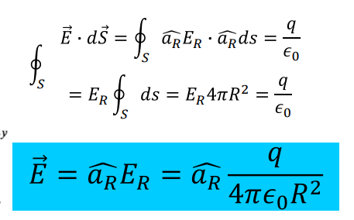
Gradient
$$V=\frac{∂}{∂x}\hat{a_{x}}+\frac{∂}{∂y}\hat{a_{y}}+\frac{∂}{∂z}\hat{a_{z}}$$
$$∇V=\frac{∂}{∂r}\hat{a_{r}}+\frac{1}{r}\frac{∂}{∂ϕ}\hat{a_{ϕ}}+\frac{∂}{∂z}\hat{a_{z}}$$
$$∇V=\frac{∂}{∂r}\hat{a_{r}}+\frac{1}{r}\frac{∂}{∂θ}\hat{a_{θ}}+\frac{1}{r*\sin{(θ)}}\frac{∂}{∂ϕ}\hat{a_{ϕ}}-$$
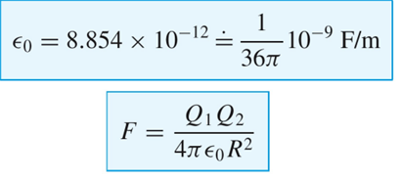
Divergence
$$div A=\frac{∂*A_{x}}{∂x}+\frac{∂*A_{y}}{∂y}+\frac{∂*A_{z}}{∂z}$$
$$div A=\frac{1}{r}*\frac{∂\left(r*A_{r}\right)}{∂x}+\frac{1}{r}*\frac{∂*A_{ϕ}}{∂y}+\frac{∂*A_{z}}{∂z}$$
$$div A=\frac{1}{r^{2}}*\frac{∂*\left(r^{2}*A_{r}\right)}{∂r}+\frac{1}{r*\sin\left(θ\right)}*\frac{∂}{∂θ}\left(\sin\left(θ\right)*A_{θ}\right)+\frac{1}{r*\sin\left(θ\right)}\frac{∂*A_{ϕ}}{∂ϕ}$$
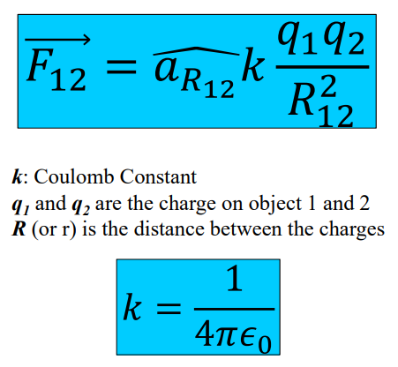
Transform to cylindrical
$$\left[\begin{matrix}A_{x} \\ A_{y} \\ A_{z}\end{matrix}\right]=\left[\begin{matrix}\cos\left(ϕ\right) & -sin\left(ϕ\right) & 0 \\ \sin\left(ϕ\right) & \cos\left(ϕ\right) & 0 \\ 0 & 0 & 1\end{matrix}\right]*\left[\begin{matrix}A_{r} \\ A_{ϕ} \\ A_{z}\end{matrix}\right]$$
$$x=r*\cos\left(ϕ\right), r=\sqrt{x^{2}+y^{2}}$$
$$y=r*\sin\left(ϕ\right), ϕ=\tan^{-1}\left(\frac{y}{x}\right)$$
$$z=z$$
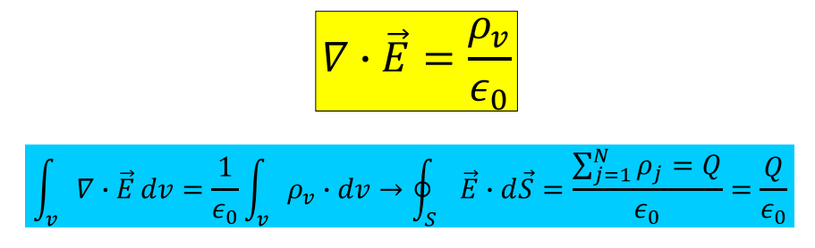
Transform to spherical
$$\left[\begin{matrix}A_{x} \\ A_{y} \\ A_{z}\end{matrix}\right]=\left[\begin{matrix}\sin\left(θ\right)*\cos\left(ϕ\right) & \cos\left(θ\right)*\cos\left(ϕ\right) & -\sin\left(ϕ\right) \\ \sin\left(θ\right)*\sin\left(ϕ\right) & \cos\left(θ\right)*\sin\left(ϕ\right) & \cos\left(ϕ\right) \\ \cos\left(θ\right) & -\sin\left(θ\right) & 0\end{matrix}\right]*\left[\begin{matrix}A_{r} \\ A_{θ} \\ A_{ϕ}\end{matrix}\right]$$
$$x=r*\sin\left(θ\right)*\cos\left(ϕ\right), r=\sqrt{x^{2}+y^{2}+z^{2}}$$
$$y=r*\sin\left(θ\right)*\sin\left(ϕ\right), θ=\tan^{-1}\left(\frac{\sqrt{x^{2}+y^{2}}}{z} \right)$$
$$z=r*\cos\left(θ\right), ϕ=\tan^{-1}\left(\frac{y}{x}\right)$$
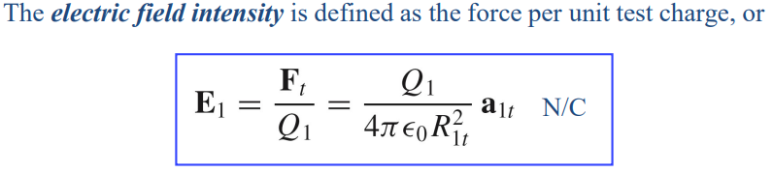
Cross product
$$a×b=\left[\begin{matrix}i & j & k \\ a_{1} & a_{2} & a_{3} \\ b_{1} & b_{2} & b_{3}\end{matrix}\right]=i\left(a_{2}b_{3}-a_{3}b_{2}\right)-j\left(a_{1}b_{3}-a_{3}b_{1}\right)+k\left(a_{1}b_{2}-a_{2}b_{1}\right)$$

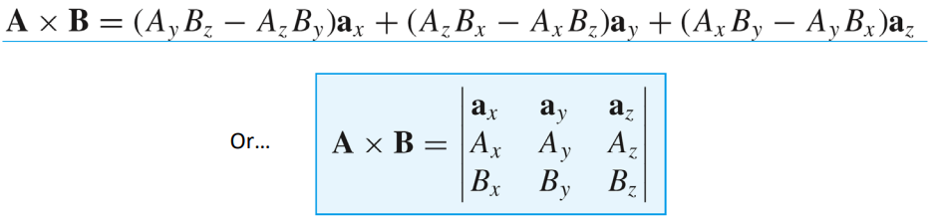
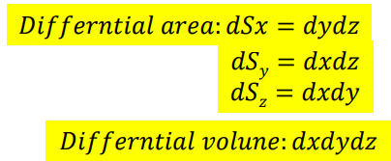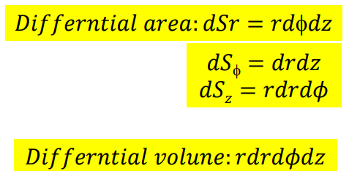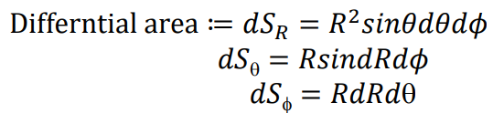
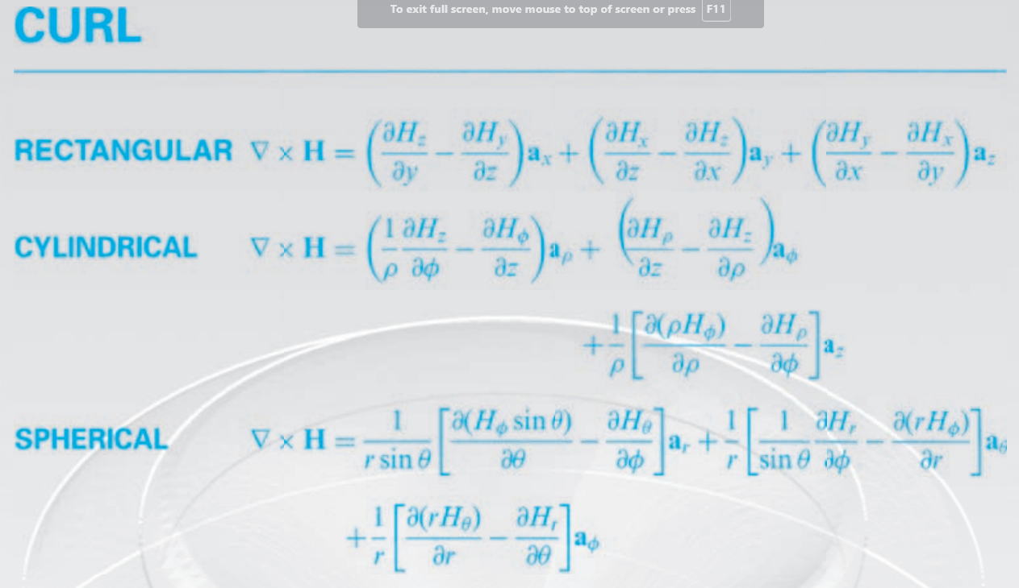
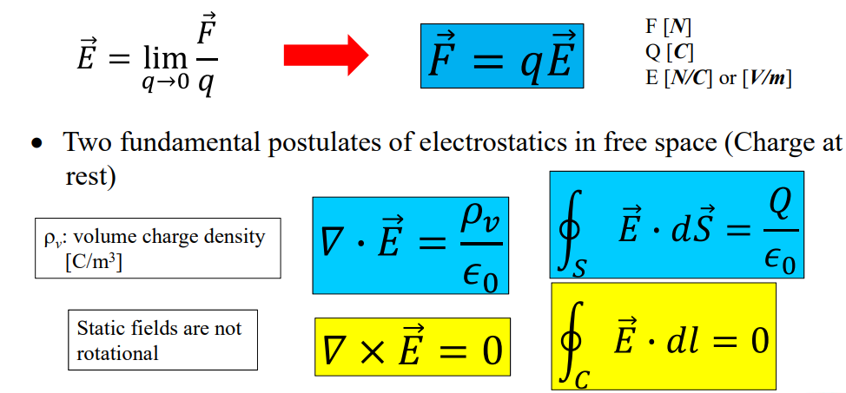

(e) [4 pts] the perpendicular distance from the origin to vector $\vec{B}$
$$θ=\cos^{-1}\left(\frac{\vec{V}⋅\vec{B}}{\left|\vec{V}\right|*\left|\vec{B}\right|}\right)=90°→\frac{\vec{V}⋅\vec{B}}{\left|\vec{V}\right|*\left|\vec{B}\right|}=0$$
$$\vec{B}=〈-1, -5,-1〉$$
The point where the perpendicular line will intersect vector $\vec{B}$ is modeled by this equation:
$$\vec{P_{X}}=P_{1}+\vec{B}*x, where x is the distance the point is from P1$$
$$\vec{P_{X}}=\left(2-1*x\right),\left(3-5*x\right),\left(3-1*x\right)$$
The perpendicular Vector will be from P_{X} to the origin, so it is modeled by the following formula
$$\vec{V}=0-\left(2-x\right),0-\left(3-5x\right),0-\left(3-x\right)=〈\left(x-2\right), \left(5x-3\right),\left(x-3\right)〉$$
$$\left|\vec{V}\right|=\sqrt{{\left(x-2\right)}^{2}+{\left(5x-3\right)}^{2}+{\left(x-3\right)}^{2}}$$
$$\left|\vec{B}\right|=\sqrt{{\left(-1\right)}^{2}+{\left(-5\right)}^{2}+{\left(-1\right)}^{2}}=\sqrt{27}$$
$$\vec{V}⋅\vec{B}=(-1)*\left(x-2\right)+\left(-5\right)*\left(5x-3\right)+\left(-1\right)*(x-3)$$
$$Solve for x:$$
$$\frac{\left(-1\right)*\left(x-2\right)+\left(-5\right)*\left(5x-3\right)+\left(-1\right)*\left(x-3\right)}{\sqrt{{\left(x-2\right)}^{2}+{\left(5x-3\right)}^{2}+{\left(x-3\right)}^{2}}+\sqrt{27}}=0→$$
$$\left(-1\right)*\left(x-2\right)+\left(-5\right)*\left(5x-3\right)+\left(-1\right)*\left(x-3\right)=0→$$
$$\left(2-x\right)+\left(15-25x\right)+\left(3-x\right)=0→20-27x=0→x=\frac{20}{27}$$
Input x back into Vector V to find the magnitude
$$\vec{V}=〈\left(x-2\right), \left(5x-3\right),\left(x-3\right)〉→〈\left(\frac{20}{27}-2\right), \left(5*\frac{20}{27}-3\right),\left(\frac{20}{27}-3\right)〉$$
$$\left|\vec{V}\right|=\sqrt{{\left(\frac{20}{27}-2\right)}^{2}+{\left(5*\frac{20}{27}-3\right)}^{2}+{\left(\frac{20}{27}-3\right)}^{2}}=\frac{\sqrt{582}}{9}≅2.6805$$

